**MythBuster.AI: Product Technology Roadmap**

**Year 1: Foundation and Initial Development**

**Q1-Q2: Core Technology Development**

* Develop initial machine learning models for:
  + Image manipulation detection
  + Video deepfake identification
  + Audio authenticity verification
* Build robust feature extraction algorithms
* Create baseline AI training datasets
* Establish a multi-modal analysis framework

**Q3-Q4: Prototype and Initial Testing**

* Develop MVP (Minimum Viable Product)
* Conduct initial accuracy and performance testing
* Begin integration with sample media platforms
* Create initial user interface for real-time verification
* Implement first version of cross-media detection algorithms

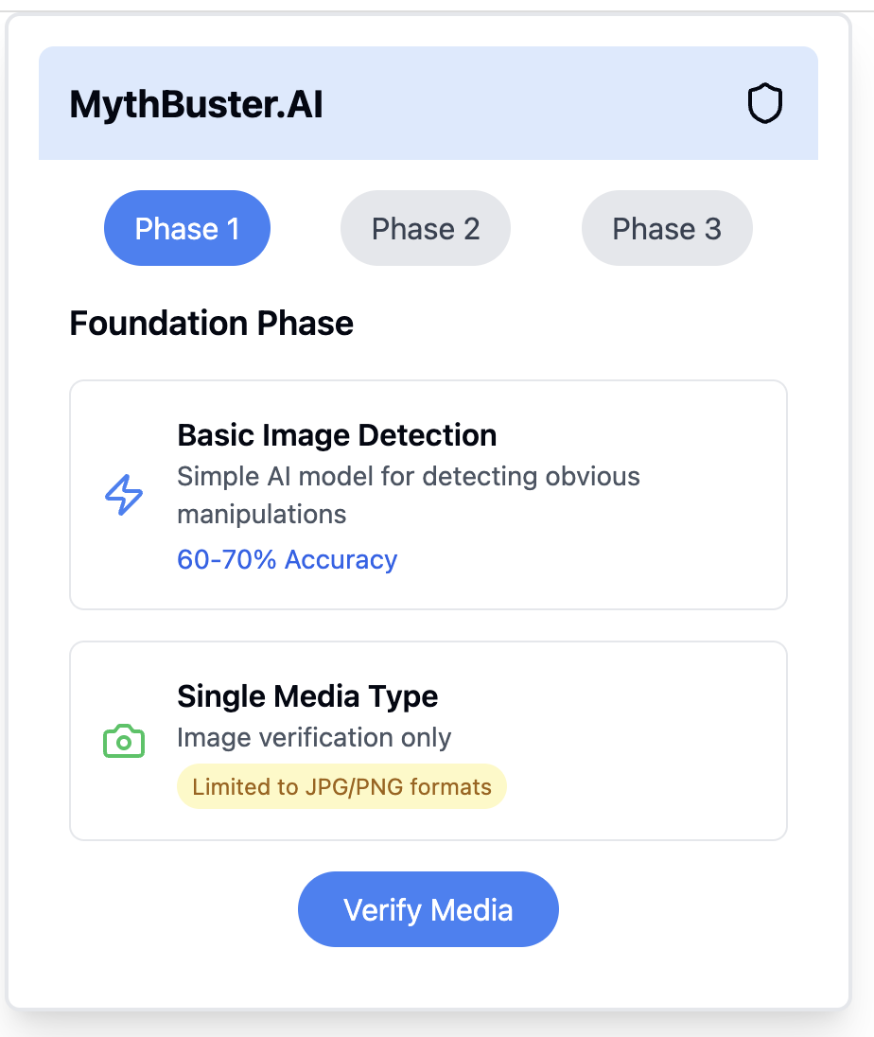

**Year 2: Advanced Capabilities and Scaling**

**Q1-Q2: Advanced AI and Machine Learning Enhancements**

* Implement advanced deep learning architectures
* Develop more sophisticated neural network models
* Enhance real-time processing capabilities
* Improve detection accuracy across multiple media types
* Begin developing industry-specific detection modules

**Q3-Q4: Platform Integration and Expansion**

* Create API for easy integration with social media platforms
* Develop browser extensions for instant verification
* Build enterprise-level authentication tools
* Implement cloud-based scalable infrastructure
* Begin international market expansion

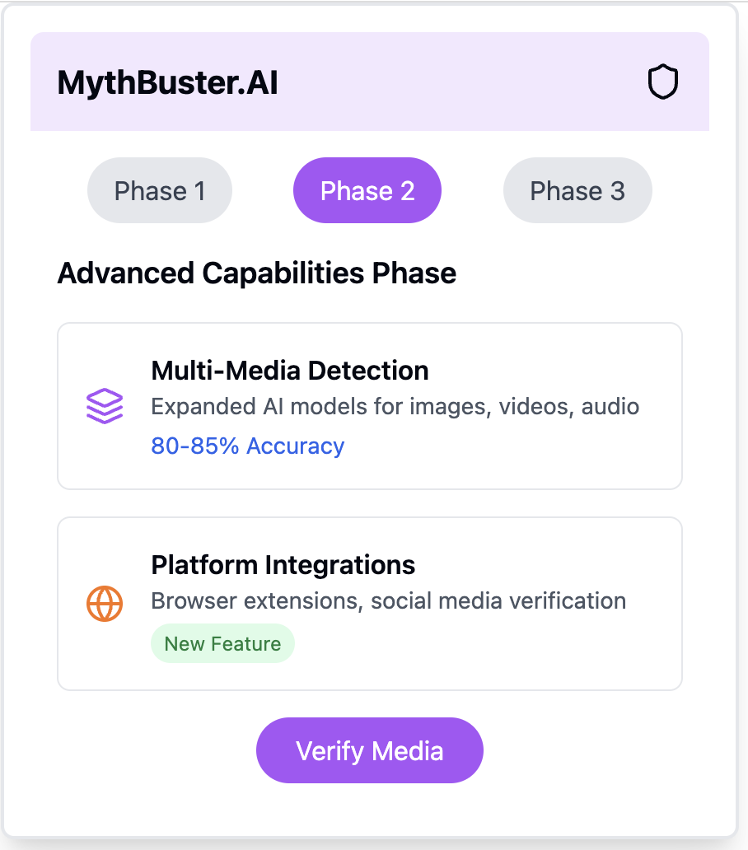

**Year 3: Global Deployment and Advanced Features**

**Q1-Q2: Global Authentication Network**

* Develop collaborative AI learning network
* Create global deepfake signature database
* Enhance cross-cultural and multilingual detection capabilities
* Implement advanced blockchain-based verification mechanisms
* Develop sophisticated reputation scoring system

**Q3-Q4: Advanced Research and Ethical AI**

* Establish AI ethics review board
* Develop privacy-preserving detection techniques
* Create transparent AI decision-making processes
* Implement continuous learning and adaptation mechanisms
* Begin research into predictive deepfake prevention

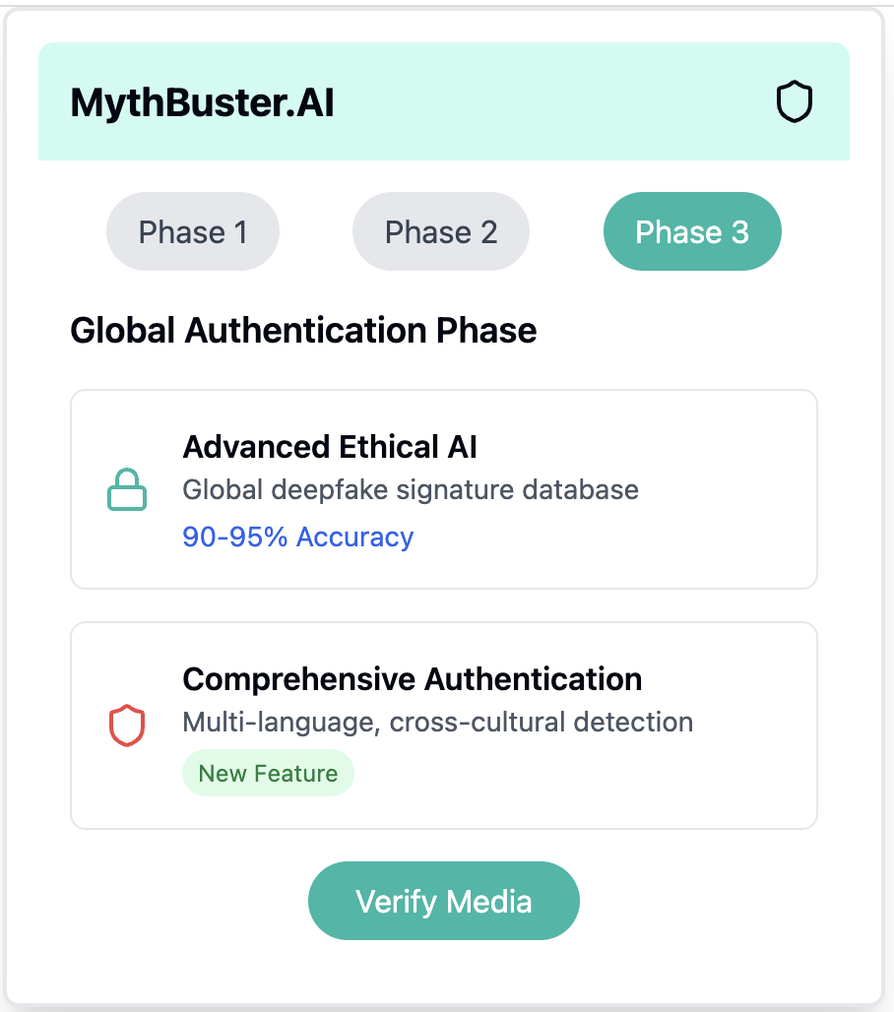

**Technology Stack Considerations**

* Machine Learning Frameworks: PyTorch, TensorFlow
* Backend: Kubernetes, Docker
* Cloud Infrastructure: AWS, Google Cloud
* Programming Languages: Python, JavaScript
* Database: MongoDB, PostgreSQL
* Real-time Processing: Apache Kafka
* Security: Blockchain integration, advanced encryption

**Key Performance Indicators (KPIs)**

* Detection Accuracy Rate
* Processing Speed
* False Positive/Negative Rates
* User Adoption Metrics
* Platform Integration Depth

**Ethical and Privacy Commitments**

* Transparent AI decision-making
* User privacy protection
* Unbiased content assessment
* Continuous algorithmic fairness evaluation

